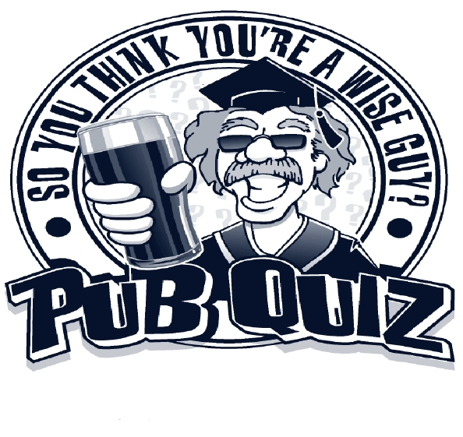
English
Department
Bring some buddies
Form a team of up to 5

prizes!
drinks!
Please don’t bring your own drinks


When? Thursday 17 January 2013 Where? Cafeteria Phil I 8pm Am Hubland

